1) Give an example of a binary number. (While a number such "1" can be a binary, decimal, and hexidecimal number, try coming up with an examples that better illustrates the differences between the different bases of numbers.)

(0=0) (1=1) (10=2) (11=3)(100 = 4)(101=5)(111=7)

these are examples of binary code translated into decimal numbers.

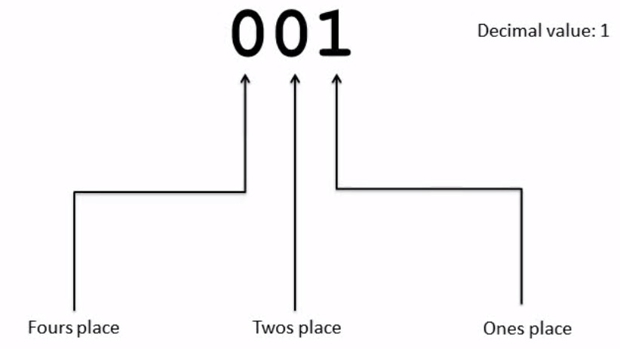

2) Give an example of a decimal number.

decimal numbers range from 0-9 in order to get to ten, you reset the ones place back to zero and place a one on the tens place.

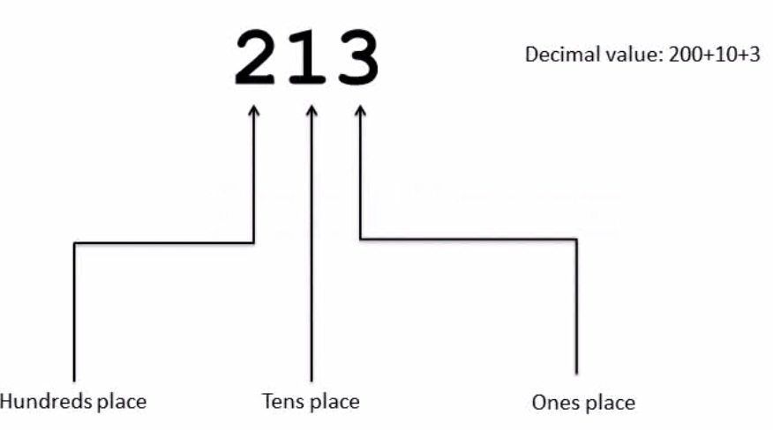

3) Give an example of a hexidecimal number.

hexadecimals range from 0 - 9,

10 = A, 11 = B , 12 = C, 13 = D, 14 = E, 15 = F.

another difference about the hexadecimal is that there is a ones place, a sixteens place and then two hundred and fifty sixs place. making the codes longer, and more complex.

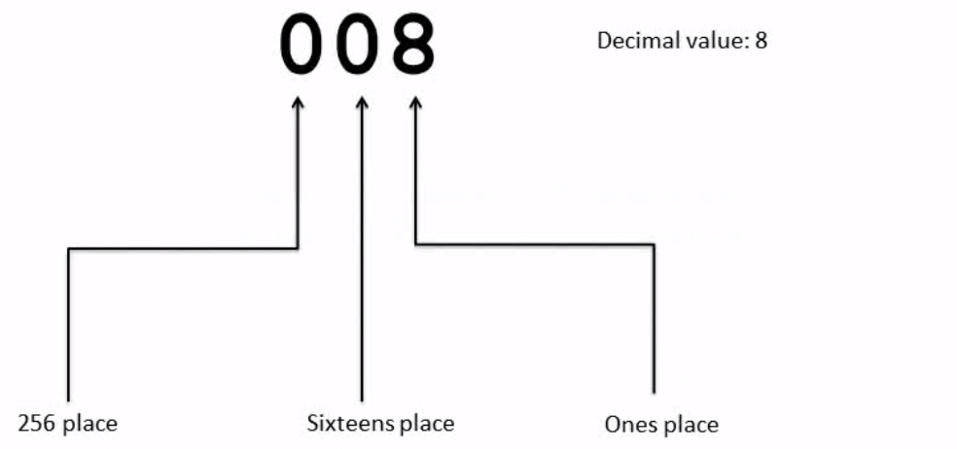

4) Convert the numbers 1, 10, 100, 1000, and 10000 from binary to decimal.

1 = 1

10 = 2

100 = 4

1000 = 8

1 0000 = 16

5) What is a compiler?

a compiler translates source into machine code for it to be understood by computers.

6) What is source code?

source code is what the user inputs.

70) What is machine language?

machine language is what the source code gets translated into, in order for computers to understand it.

8) What is a first generation language?

fist genereation language is binary code.

9) What is a second generation language?

assembly languages are known as second generation languages.

10) What is a third generation language?

things like python or C

11) What is an interpreter?

The interpreter translates source code to machine language and viceversa.